How to Install Option A Despite Microsoft’s Insistence that They Know Best
From the NYSPRL Download Software page (https://www.nysprl.com/ClientSoftware.htm)
- Click on Option A’s Download link
- Browser pops up. This is from Edge, other browsers may be slightly different.
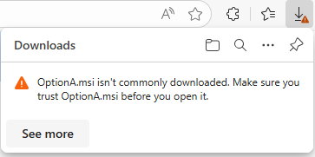
- Hover over the “OptionA …” text. You should see a trash can and three dots.
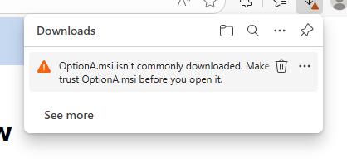
- Click on the three dots next to the trash can (NOT the three dots next to the magnifying glass and pushpin). There are several options available: Delete, Keep, Report this file as safe, Learn more, Copy download link. Choose Keep.
- A new popup appears!
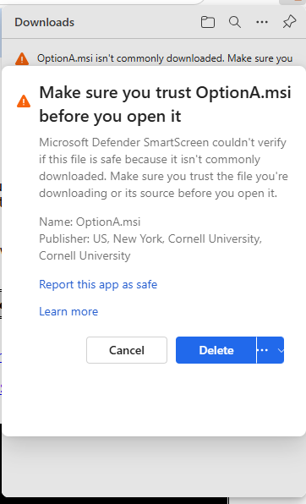
- Ignore Cancel and Delete as well as “Report this app as safe” and “Learn more”. Click on the three dots again and choose “Keep anyway”.
- Back at the original Downloads popup, but now it looks different:
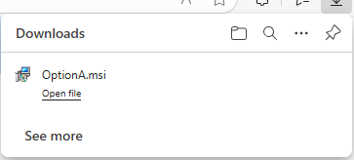
- You should be able to click on “Open file”
  - Or hover over the file name to expose two more icons:
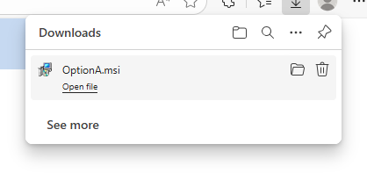
  - Click on the folder to open the Downloads folder and install OptionA.msi from there.
- Either way, Windows may try again to stop you. Proceed to step 10 if you see the dialog below. See the S Mode section below if you don’t.
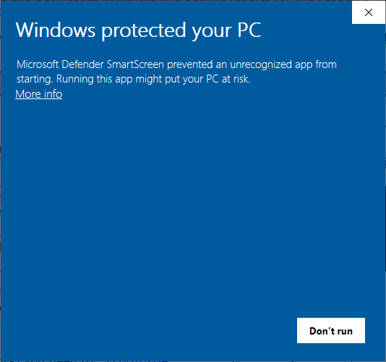
- Ignore “Don’t run” again. Instead, click on “More Info”. The dialog changes.
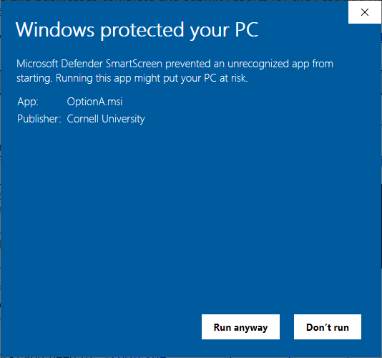
- Finally, click on “Run anyway”.
- The Option A InstallShield Wizard opens. You are ready to install. Finally. Hurrah.

S Mode:
Some Windows installations are preset with S Mode, a Special Secure Mode that only allows installation of programs from the Windows Store. Instead of (or in addition to?) step 9 above, you might get a message from Windows preventing you from installing because S Mode is on; in this case, there should be a button (captioned “Get” though I don’t know why) to turn S Mode off. After which, try, again with the msi (or maybe it automatically continues after you turn S Mode off.

